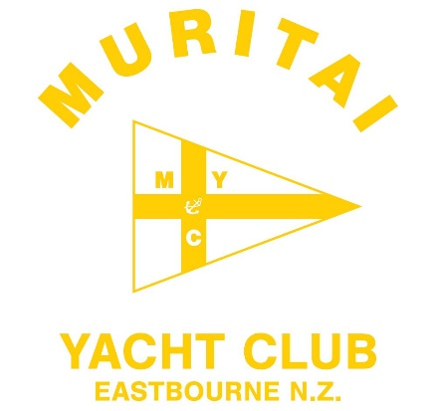

NOTICE OF RACE

ANZAC Day Regatta 2025

Organising Authority:
Muritai Yacht Club, Marine Parade, Eastbourne, Lower Hutt
www.myc.org.nz

Friday 25 April 2025
______________________________________________________

1 RULES

  - The Regatta will be governed by the rules as defined in The Racing Rules of Sailing 2021-2024.

  - The Yachting New Zealand Safety Regulations Part I shall apply.

  - For protests where only a Rule of Part 2 or Rule 31 is alleged to have been broken, an arbitration will be offered prior to any formal hearing.

2 ELIGIBILITY AND ENTRY

2.1 The regatta is open to all sailors who are financial members of a club recognised by Yachting New Zealand, and all centreboard class yachts.

2.2 Eligible yachts may enter by completing an entry form and presenting it on the day, together with the required fee at Muritai Yacht Club. The entry fee is $10 per senior class yacht, and $5 for junior and youth classes.

3 SCHEDULE

3.1 a) Registration: Friday 25 April 2025 from 1200 hours to 1300 hours.
b) Briefing: All classes 1320 hours.

3.2 Number of Races: Friday 25 April 2025: All classes will sail two (2) races.

3.3 The scheduled time of the warning signal for the first race is 1345 hours.

  - No warning signal will be made after 1600 hours.

  - There will be no reserve day.

4 SAILING INSTRUCTIONS

4.1 The sailing instructions will be available at registration and from www.myc.org.nz ahead of the event.

5 VENUE

5.1 The races will be held in the vicinity of Muritai Yacht Club.

6 COURSES

6.1 Courses to be sailed will be either Triangular or Trapezoid

6.2 Exact courses for each class will be displayed on the official club noticeboard and presented at the briefing.

7 SCORING

7.1 The low point scoring system will be used.

7.1 One race is required to constitute a series for each event.

7.2 A boat’s series score will be the total of her race score for each event. No races shall be dropped.

8 LAUNCHING

8.1 Unless otherwise directed by the Organising Authority, all competing boats and equipment shall be launched and retrieved from directly in front of Muritai Yacht Club.

10. DISCLAIMER OF LIABILITY

Competitors participate in the Regatta entirely at their own risk. See Rule 4, Decision to Race. The organising Authority will not accept any liability for material damage or personal injury or death sustained in conjunction with or prior to, during, or after the Regatta.

11. FURTHER INFORMATION

Contact: muritaiyachtclub@gmail.com

